**Bug report – Error message not display .**

1. [Feature Name] Title - Message field
2. Environment - SIT Envoirment
3. Steps to Reproduce –
   1. Go to the tendable url.
   2. Home page should be display .click on contact us field.
   3. Go to Marketing functionality and click on contact us button.
   4. Fill up all the details like full name, Organisational Name , Phone , Email, Job role.
   5. Empty the field of Enter the message here.
   6. Click on I agree radio button.
   7. Click on submit button .

1. Expected Result - Error message should be display .
2. Actual Result - Error message not display .
3. Visual Proof (screenshots, videos, text)

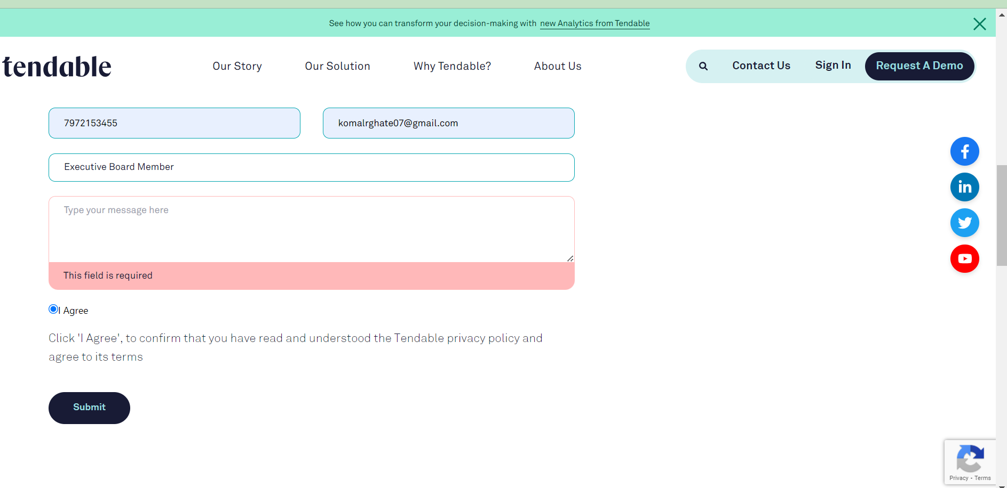

1. Severity/Priority

Severity – low severity

Priority - High prioity